Nama : Nurul Chotimah

NIM : 18090046

Kelas : 5A

**Praktikum 3**

1. Source Code

view-from-matakuliah.php->application/views

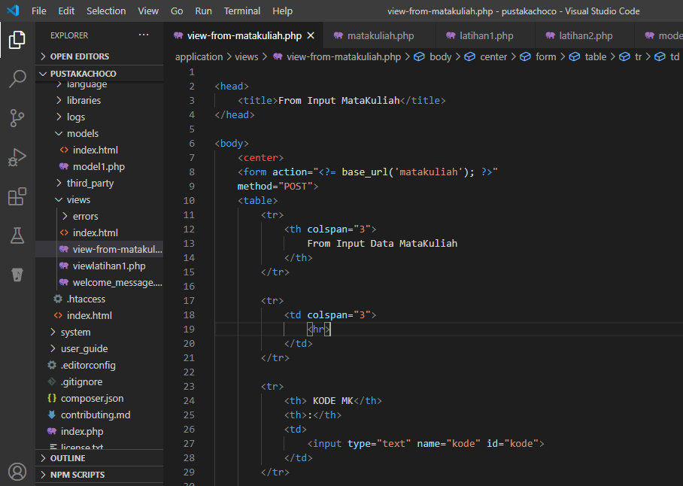

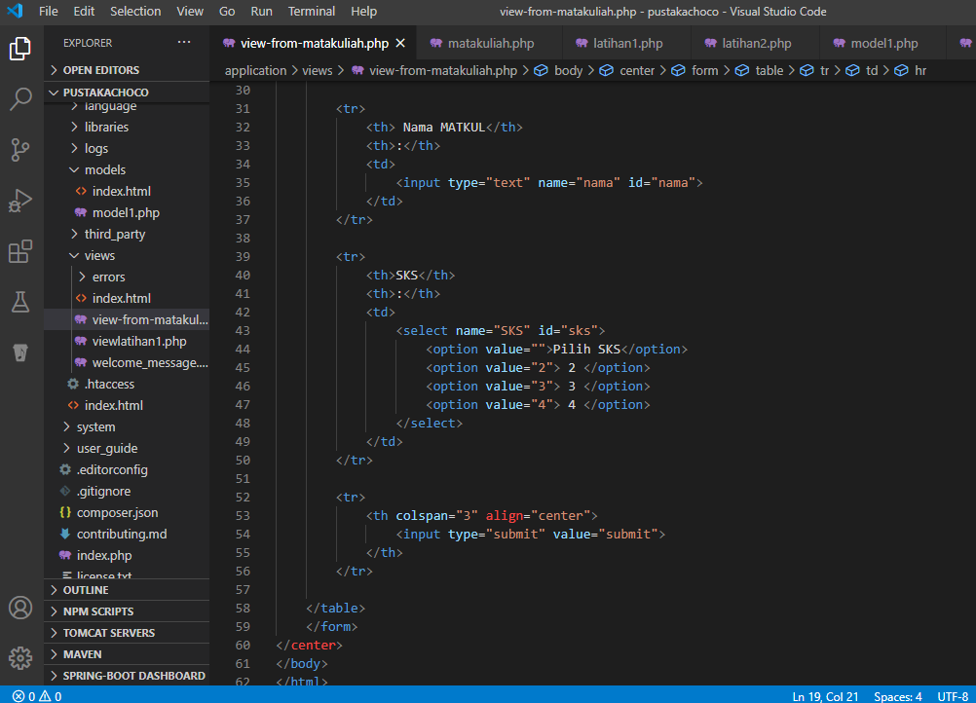

matakuliah.php->application/controllers

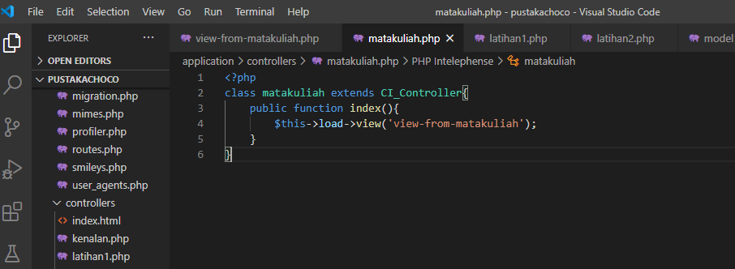

1. Hasil URL

<http://localhost/5/pustakachoco/index.php/matakuliah>

1. Capture Hasil

